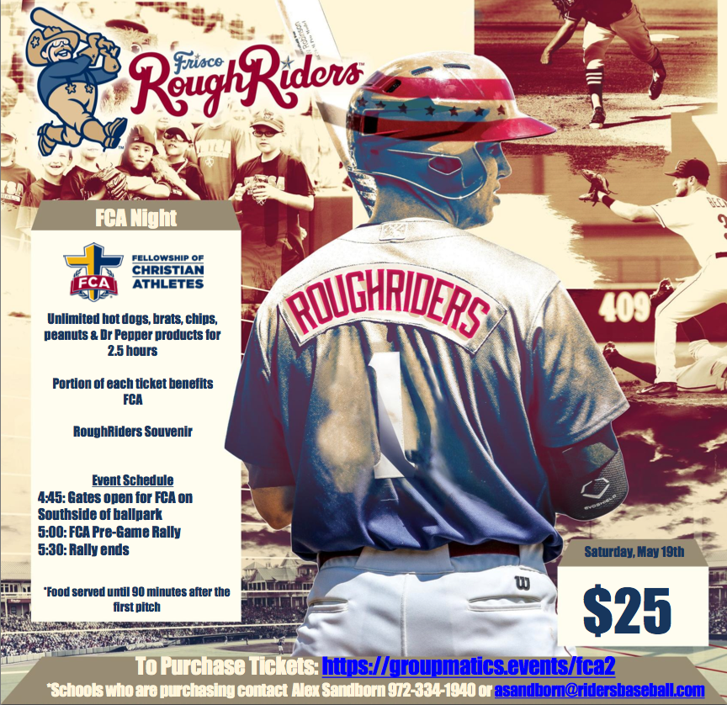

Paradise Junior High FCA Field Trip to the Frisco Rough Riders Game
You're invited to join us on Saturday, May 19th for FCA's Night at the Ballpark! The $25 ticket includes:
- Unlimited hot dogs, brats, chips, peanuts & Dr Pepper products for 2.5 hours
- Portion of each ticket benefits FCA
- Rough Riders Souvenir
The buss will leave school at 2:15p.m. and return around 11p.m (we will call on the ride home)
The cost per child is $25 for unlimited hotdogs, brats, chips, peanuts, and drinks; game ticket, and souvenir. In order for your child to participate in’ the field trip, you must complete the permission slip below and return it to the school by April 23.
***************************************************************************
My child ___________________________ has my permission to go on-the field trip. In the event of a medical emergency ____________________________ has my permission to seek and authorize medical treatment for __________________________. Our family physician is _______________________________ who can be reached at ______________________ and has access to our medical history.
My child has the following allergies: _________________________________
has received the following inoculations: __________________________________________
and is taking the medication as listed below: ________________________________________
________________________________ ____________________________
(Parent Signature) (Home Telephone Number)
________________________________ ____________________________
(Relationship) (Work Telephone Number)
In case of an emergency and parent(s) cannot be contacted, please list alternate contacts,
Name________________Relationship __________________________________________ Phone __________________________________

